**KUNENE BONGOKUHLE 202004427**

**MAMBA MHLENGI 202004122**

**GUMEDZE THABISO 202002051**

**MOHALE HALA 202003908**

**NSIBANZDE SEAN 202003639**

**UNESWA STUDENT RESIDENCE MANAGEMENT SYSTEM**

**INTRODUCTION**

**Abstract**

A student residence information system is a software that provides online services for students residing on campus hostels. It is a web based application that will controlled by the hostel management, where they can add, update or delete from the database and possibly make any needed modifications to the captured data. Students will also be able to log in to the system for any services they need, it could be searching for availability of rooms for students willing to reside on campus, requesting for maintenance services by students already allocated rooms, and many more.

**Background information**

The University of Eswatini’s warden’s office has over the years used manual/paper system residence allocation system. This has brought about a backlog in room allocation, and loss of student records. Over the years, students seeking on-camp residence have been queuing in long lines looking for room allocation. The system is ineffective to both the student and the head warden. The warden’s office has to file all on-camp students’ records in shelves, the storage of the files is limited and the retrieval of student files is tedious due to the high number of students staying on campus.

Moreover, students have not been able to interact with the residence system. Students do not have the convince to look into whether the warden’s office has rooms available or not. In addition, they have to report maintenance issues physically at the warden’s office. The system is rather not transparent and does not meet democratic, efficiency and accountability standards. Another issue with the maintenance of the student dooms is the fact that the paperwork given to the maintenance office is sometimes lost or misplaced which in turn leads to most of the issues being voiced out by students to be not carried out or fixed. The traditional system of filing is tedious and time consuming.

The billing of the rooms in the warden’s office is confusing to most students and can be hard to keep track of the number of days a student has been residing within campus, most of the students end up being in debt with the warden’s office with the main cause of that problem being that students can’t keep track of their accumulating bill as each day goes. Another issue with the billing services of the warden’s office is the verification process of the payment, the verification of the payment requires a student to first approach the student finance office whereby he or she has to provide proof of payment before being cleared to approach the warden’s office for room allocation. This entire process is time consuming and includes a lot of paperwork that can be hard to keep track of for both the students and the warden’s office.

Lastly, students have had issues whereby they have been allocated to rooms that have been already occupied by other students. This process has of student residence allocation has proved to be inefficient.

**Problem Statement**

The issues to be solved by this project include;

* Travelling long distances from home for allocation of rooms by the warden. Students have to travel from different parts of the country to their respective campuses in order to be allocated rooms before a semester resume. They are not allowed to move in immediately after allocation but to return at some specified date. This is time consuming and costly, especially for students who come from remote areas. With the large number of students enrolled in the institution, some may travel the long distances only to find all rooms occupied since they are allocated according to who came first.
* Student requests such as maintenance requests, room transfers, or any other necessary requests after allocation can only be done face to face with the warden. When the warden is busy or unavailable, he can’t attend to the students request regardless of an emergency of that request.
* Billing. Residence bills are paid according to the number of days stayed on campus and a students are supposed to calculate themselves to check for the amount they owe whenever they want to make some payment. This may lead to miscalculations by students paying in instalments as the semester proceeds. The miscalculations may lead to some students having their results withheld at the end of semester when they thought they settled their residence bill but they actually have not.
* Students do not have a platform to suggest some important things that will help during their stay in allocated domes (i.e. suggestion box). This can compromise students’ safety at the hostels since most important challenge they are likely face are security issues.

**LITERATURE REVIEW**

Hostels has become an opportunity to develop and improve the quality of education in most academic institutions. The desire to provide spaces for students that allow active interaction, comfort and convenience, and opportunities for socialization is foremost in universities and college planning [Ayaka Akolo Emmanuel].According to Kola Ayanlowo hostel facility management is a user friendly application specifically designed to automate, coordinate and look after all the processes of managing hostel facility.

**Existing system**

The existing system is manual based and need a lot of efforts and consumes enough time. In the existing system, we cannot apply for the hostels online and the allotment processes are done manually. This may lead to corruptions in the allocation process as well as hostel fee calculation. The existing system does not deals with mess calculation and complaint registration.

Disadvantages

* More human power
* Repetition of same procedure
* low security
* record keeping is difficult
* difficulty to handle

**Proposed system**

This system will provide full information about a student in the hostel. It will show rooms available or not and number of people in a particular room. Students who have booked and paid for the hostels will also be shown. This system will be developed using the Software Development Life Cycle with PHP and My SQL server.

**METHODOLOGY**

Tools

* HTML
* PHP
* CSS

Methods of data collection

* Ethnography: Through observation and analysis the project team was able to identify problems in the student residence system at UNESWA.
* Interview: A sample of students were interviewed about issues they face with the current system. They were asked to recommend possible solutions to these problems. Moreover, Stakeholders such as the warden’s office and bursar’s office were also interviewed about the problems of the current system and how it can be improved to best suit their working practices. as well as the development of a new system

**SYSTEM DESIGN**

1. **Data dictionary**

**Student object**

|  |  |  |
| --- | --- | --- |
| **Name** | **Description** | **Data type** |
| Student Number | Student’s number given by the university | 7 numbers |
| Title | Student’s title | 15 Characters |
| Surname | Last name of the student | 15 Characters |
| Name | First names of student | 15 Characters |
| Gender | Student’s gender coded M (Male), F (Female) | 15 characters |
| Date Birth | Student’s birth date | Date |
| Email | Student’s Email | 15 Characters |
| Home Address | Student’s address during holiday | 15 Characters |
| Email | Student’s email address | 15 Characters |
| Mobile No | Student’s Cell phone number marital status | Numbers |
| Faculty | Student’s program of study | 15 Characters |
| Year Entry | The year the student entered the University | 4 numbers |

**Warden object**

|  |  |  |
| --- | --- | --- |
| **Name** | **Description** | **Data type** |
| Admin ID | Warden’s  Identification number | 6 numbers |
| Date Birth | Date of Birthday | Date |
| Name | Wardens name | 15Characters |
| Mobile Phone | Number of his/her phone | 9 Number |

**Block object**

|  |  |  |
| --- | --- | --- |
| **Name** | **Description** | **Data type** |
| Block Code | Code given to each block | 7 numbers |
| Block Name | Actual Name of the block | 15Characters |
| Number Room | Number of rooms which are in block | 15Numbers |

**Room object**

|  |  |  |
| --- | --- | --- |
| Name | Description | Data type |
| Room Code | Code given to each room | 7 character |
| Block ID | Actual code of the block | Characters |
| Room Type | The type of rooms in that block | 10 characters |
| Price | The Charges per room | 10 numbers |
| Status | The status of room | 10 characters |

1. **Use case diagram**

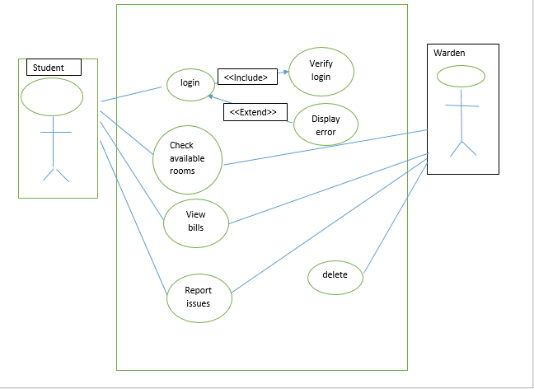

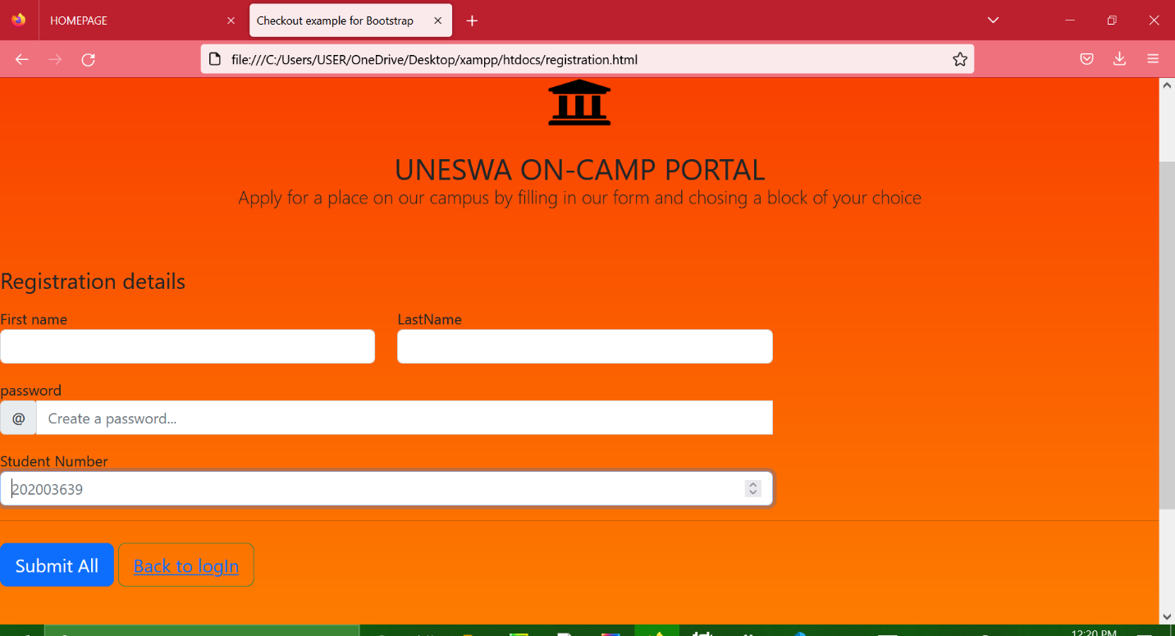

This is the registration form where the enrolled students can register to the network by filling in the registration details to be eligible for room allocation. By completing the registration details the student becomes eligible to sign into the network and browse for rooms in the campus.

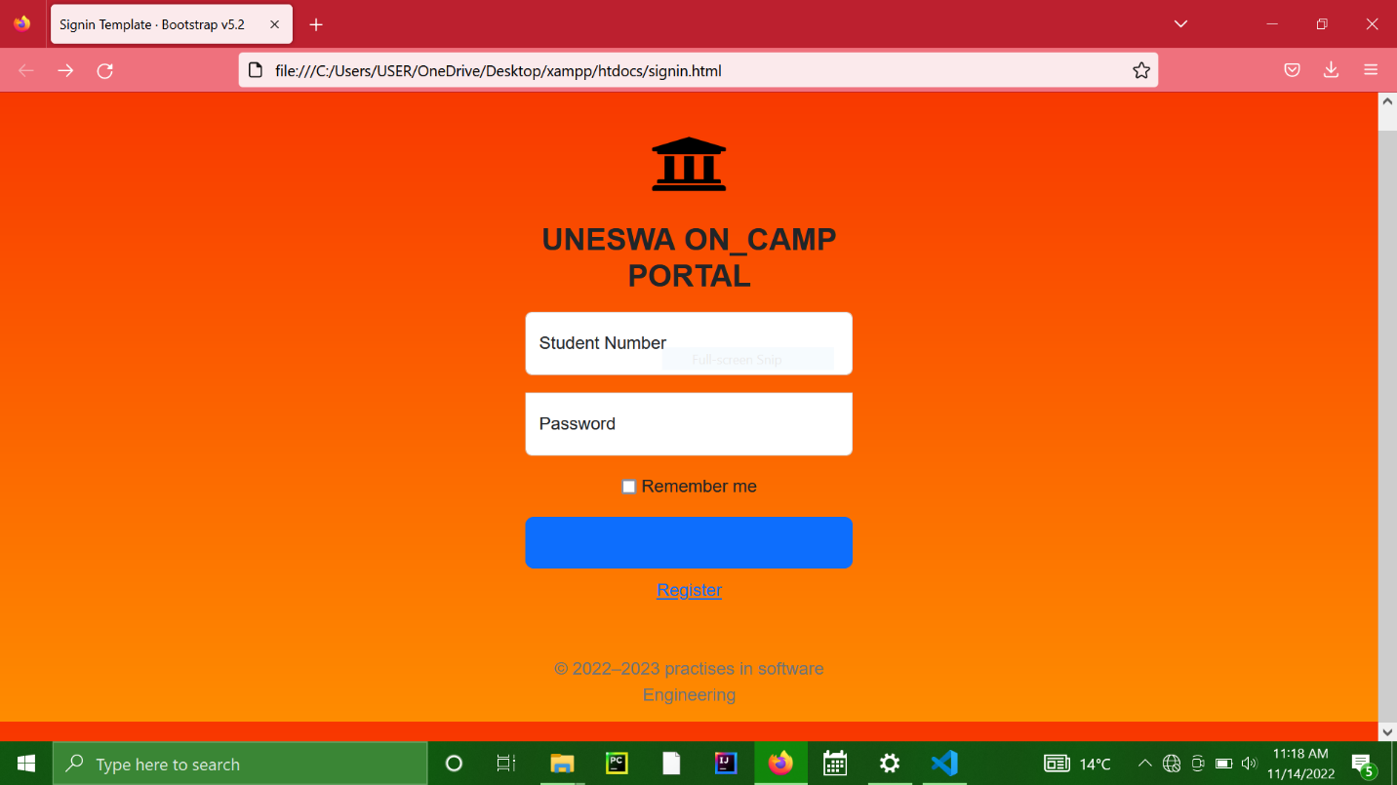

This is the sign in page , verification of the details that are registered for you to log into the network

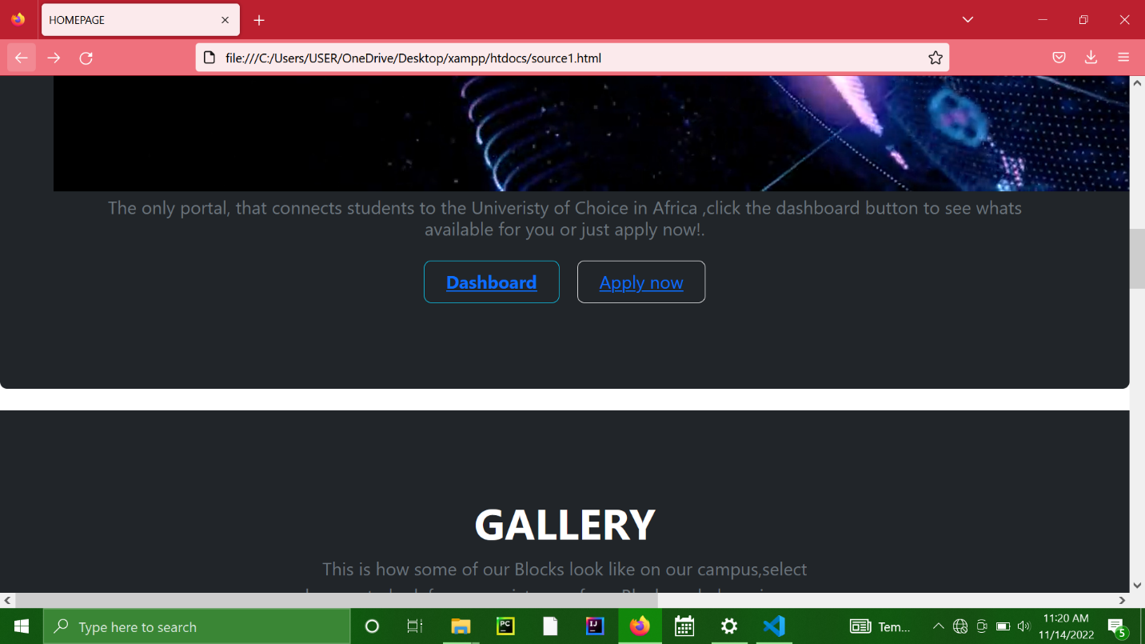

This is the homepage where you can navigate to find many details on our network such as the various blocks available , browse to look at the blocks and find different blocks that may intrigue you . You can also find the application form and comment section on this page.

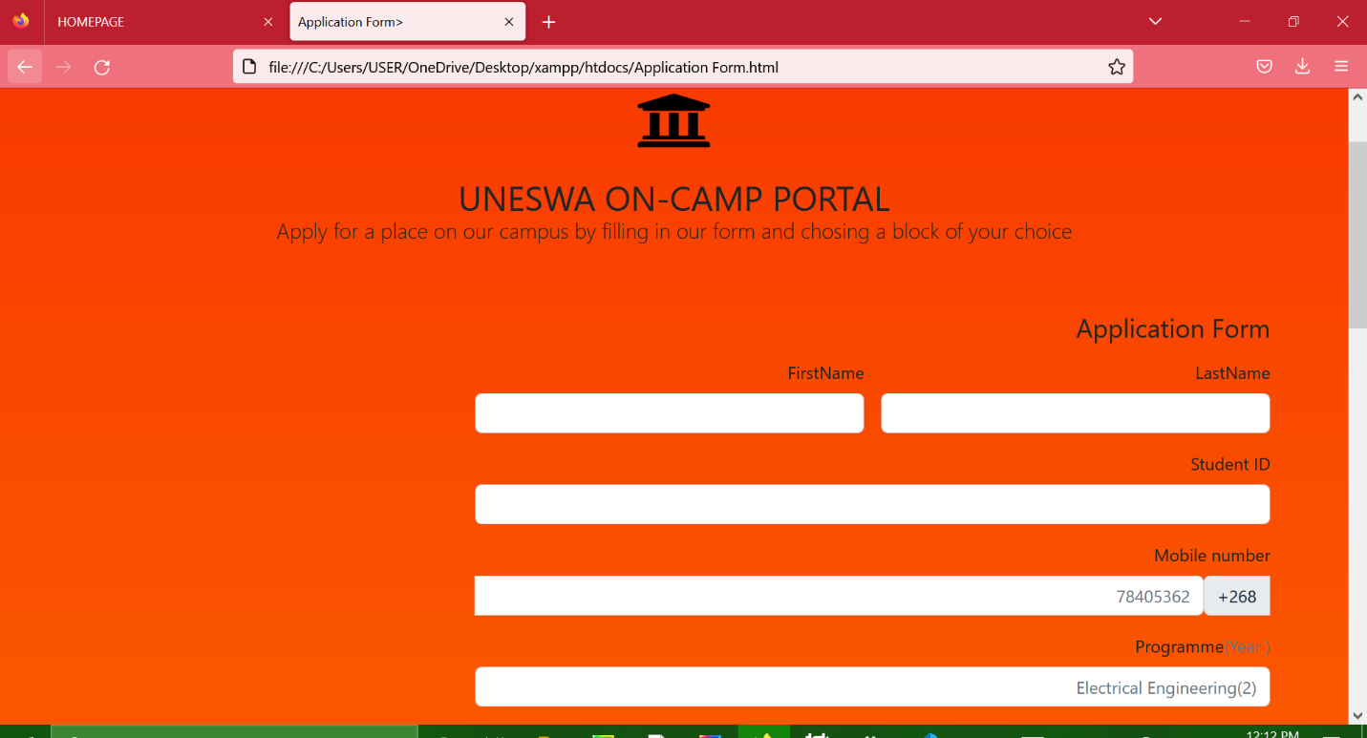

This is the application form whereby a student fills in his/her details to be submitted to the wardens office .Whereby it is previewed to see eligibility for room allocation and details of next of kin in case of emergency.

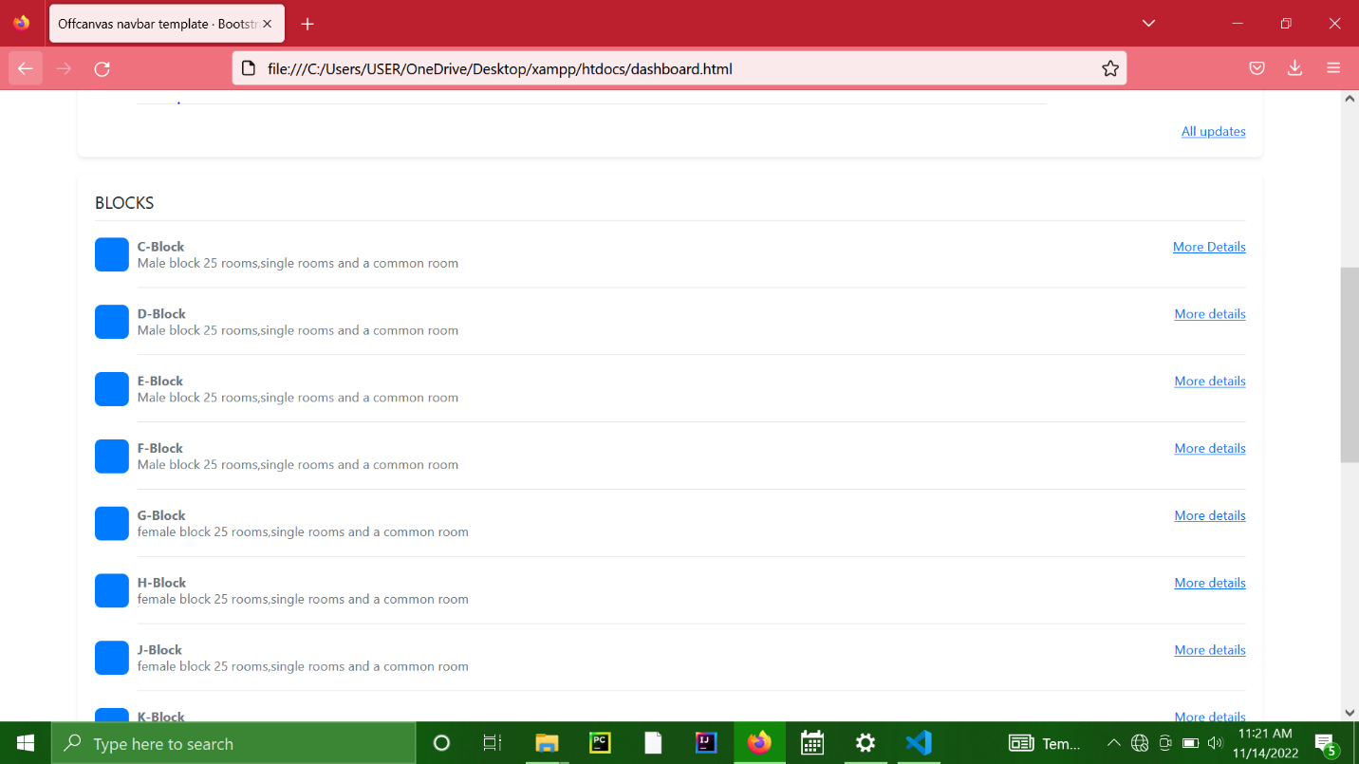

This is the dashboard; this views the different blocks that are available whereby students can navigate to their block of interest. Students can view their outstanding amount and keep track of the number of days they have been on camp

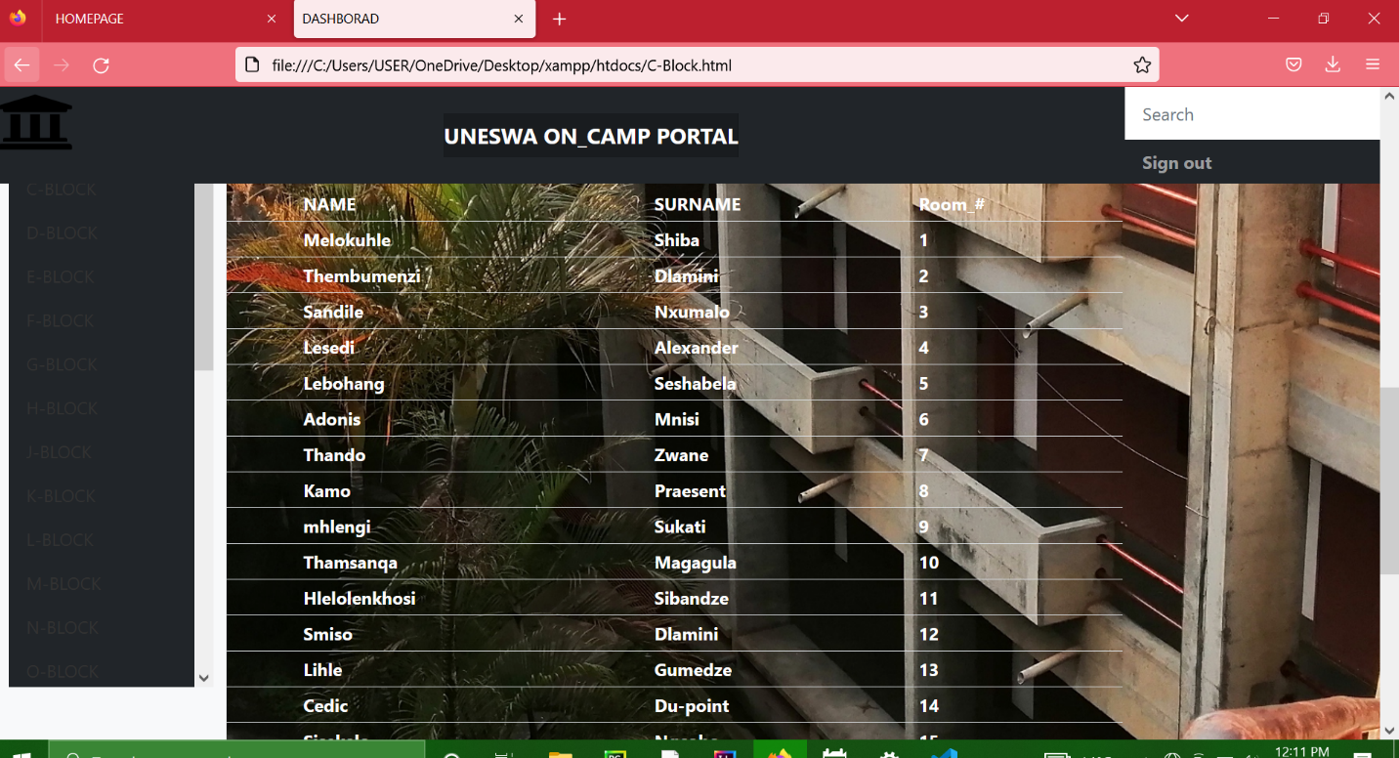

This is the block name . this shows the number of rooms available and if the room is occupied or not

**CONCLUSION AND RECOMMENDATIONS**

In conclusion, in this documentation the system was successfully implemented and it will be of great benefit to students who wish to access our network.

We recommend that our system can be improved with higher security

**REFERENCES**

Emanuel Adu Baffoe June ,2015, Hostel Management System

Ayaka Akolo Emmanuel , Design and Implementation of Online Hostel Management

Muharman Lubis , School of Industrial Engeneering, Telkom University Bandug, Indonesia